CPSC 230 – Computer Science I

Spring 2022

Final Examination

This examination is closed book and notes. There are 9 problems and 100 points possible. You have 150 minutes to earn as many points as you can.

In the questions below, whenever an explanation is required (“why?”), full credit will not be given if the explanation is not provided.

Good luck!

Name (printed): ____Andrew Ingalls_____________

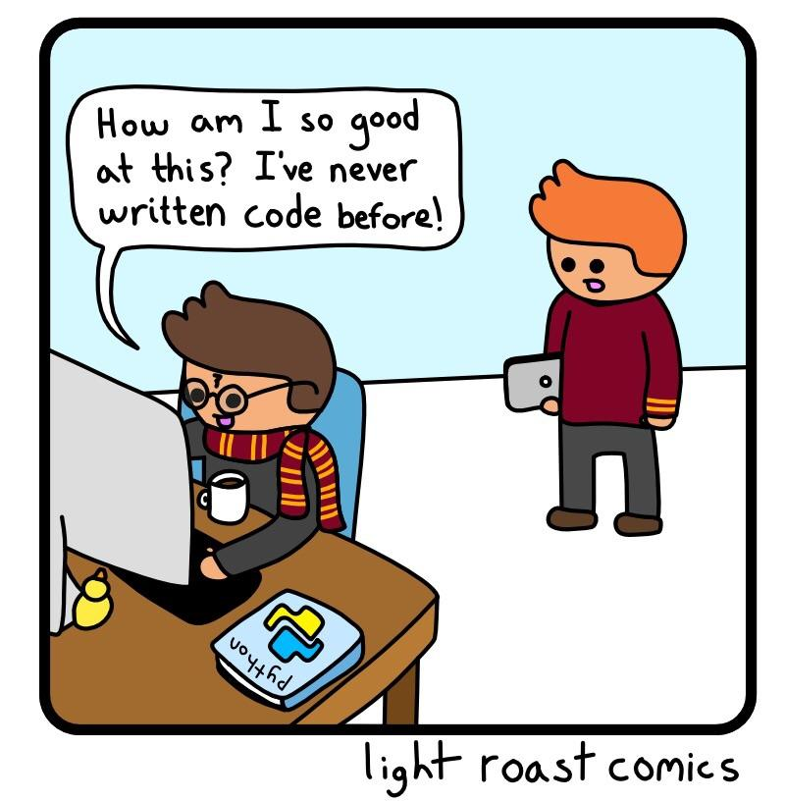

1. **(10 points)** Be sure to answer all parts:
   1. What is indexing in regards to strings, or lists?

* Indexing is referring to a specific element in a string or list and calculating its exact position.
  1. Why is it useful?
* It can be extremely useful when manipulating lists such as adding or deleting certain elements because you can choose which exact element within the list or string that you want to change or even use later for another reason.
  + 1. **(20 points)** Write a **function** that takes in a string as an argument and returns a Boolean (True/False) to determine whether or not the string is a palindrome (remember a palindrome is a string is read the same forwards and backwards). Once the function has been written continue to write a module that should continue to prompt for user input until a palindrome is entered.

* + 1. **(5 Points)** What is a function and why is it useful?
* A function is a block of code that can be used to perform a certain function depending on what is written. Later, you can refer back to that function and the code runs instead of having to write all the lines within the code block. It saves a lot of time and space within a file and reduces redundancy in the code.
  + 1. **(10 Points)** Write a python module that prompts the user for radius and height of a cylinder and prints the volume of that cylinder (Volume = π r2 h). Use the value of PI provided by the math module.

* + 1. **(5 points)** Ask your user to enter the name of her/his favorite movie. Ask if they want to enter another name. If answer is yes let them a another one. Keep asking until they say no.

* + 1. **(10 points)** What do you call spaghetti in disguise? Answer by writing the output of the following code. Show your work to portray your thought process, full credit will not be given without it.

letters = [["i", "q", "m", "S"], ["a", "!", "t", "y"], ["p", "-", "a", "q"], ["o", ".", "R", "l"], ["s", "V", "t", "-"], ["!", "r", "k", "E"], ["a", "r", "!", "P"]]

for i in range(len(letters)):

for j in range(4):

if i%2 == 0 and j%2 == 0:

char = letters[i][j]

print(char.upper())

IMPASTA!

The first for loop counts the range of lists in “letters” which is seven, the next for loop goes into each list and checks each element of the list since each list has 4 elements. The if statement checks the first list, since its element “0” the first condition is true and the 1st element in the 1st list is true it prints “I”, the next element q is false so it skips it and then the “m” is true as well so it prints that as well. Since the second list is indexed as “1” then the first if statement is false resulting in the program skipping the entire second list. It then repeats taking the first and third element of the next list, skipping the following list, taking the first and third elemet of the next list, skipping the following list and finally taking the first and third elements of the last list. The resulting output is IMPASTA!, each letter on a newline

* + 1. **(20 points)** Suppose you have a dictionary which maps integer keys from 1 to 5 to string values.

1. Create the dictionary.
2. Write a line of code that adds 6:six to the above dictionary.
3. Write a **function** that takes a dictionary key as input and returns its value.

1. **(10 points)** Write a code that writes the following text on a text file.

**Hello**

**Thank you for shopping here. We appreciate your business.**

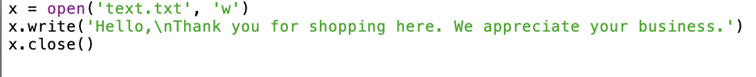

1. **(10 points)** Ask the user if they are looking forward to graduation. Print different answers depending on their answer.

